- Namespaces:
- Multiple virtual cluster boundary within one physical cluster.
- Provides scope for naming.
- Physically allocation of memory utilization
- Divide cluster resources to namespaces
- Useful for namespace specific accesses
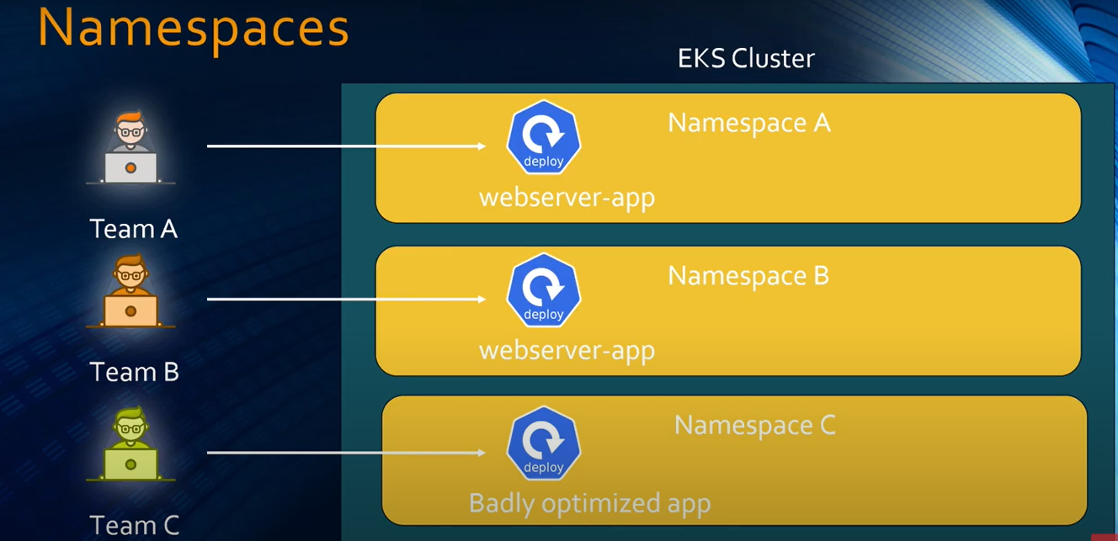
- Resource Requests and Limits
- Set appropriate requests and limits for container
- Set resources for Namespaces using ResourceQuotas
- When CPU reaches limit, it’ll throttle (observe slowness of program)
- When Memory reaches limit, Pod will be evicted
- Proper requests and limits save cost as well.
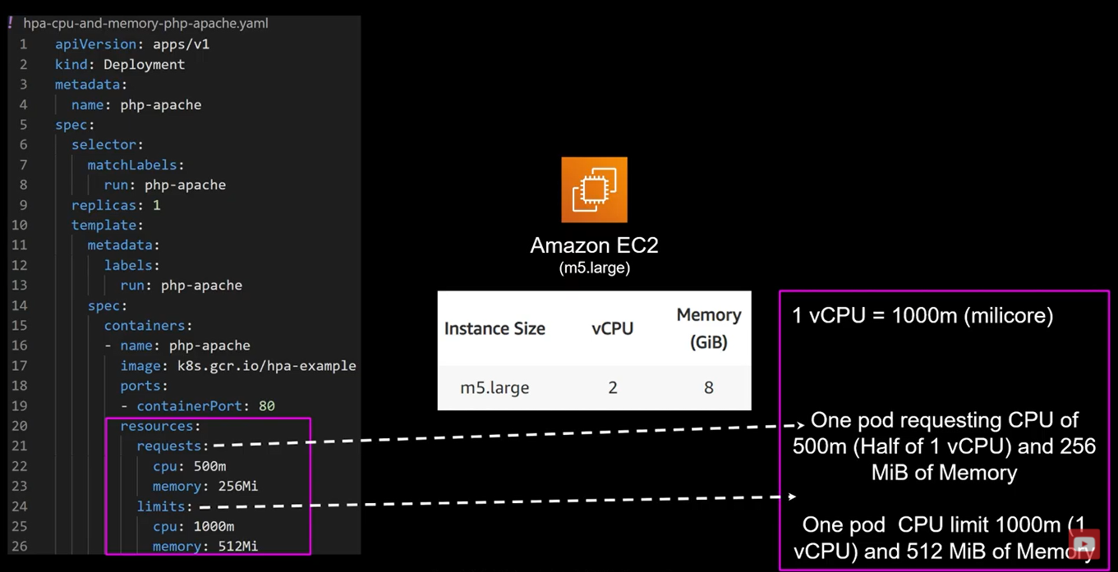
How do you cost/performance optimize K8s app?
Detect CPU/Memory waste=> Utilize Metrics server
- Use Readiness and Liveness Probe
- Your service will not work until your application up and running if your applications take 2-3 minute for warm-up?
- By default, K8s starts sending traffic to container as soon as process inside container starts
- By using Readiness probe K8s waits until application fully started, service will not send the traffic.
- Application stuck e.g., your cpu reaches limit and your application throttling very badly, K8s things everything is fine and continually sending traffic to this pod
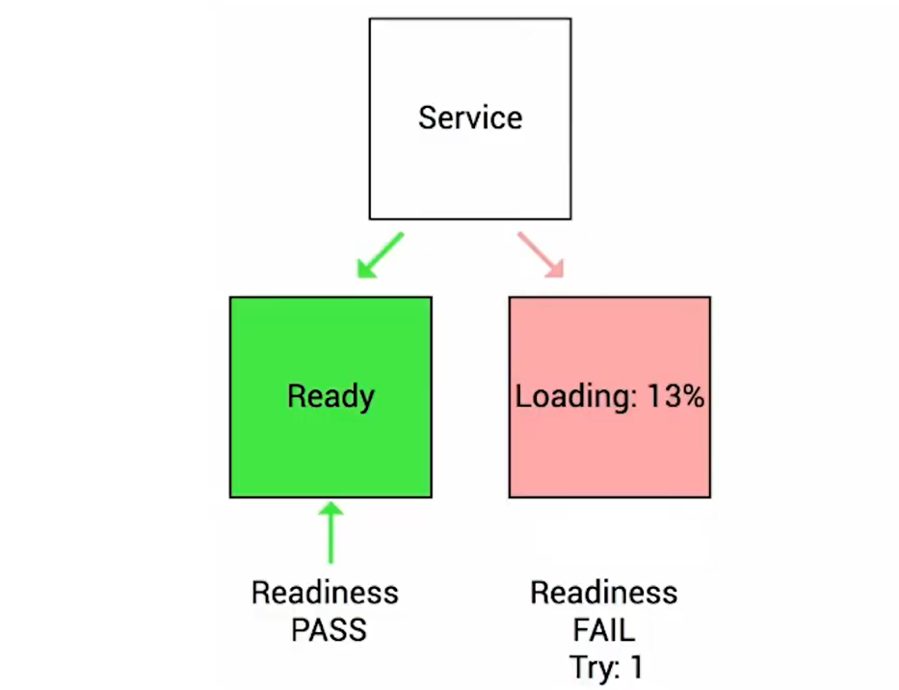
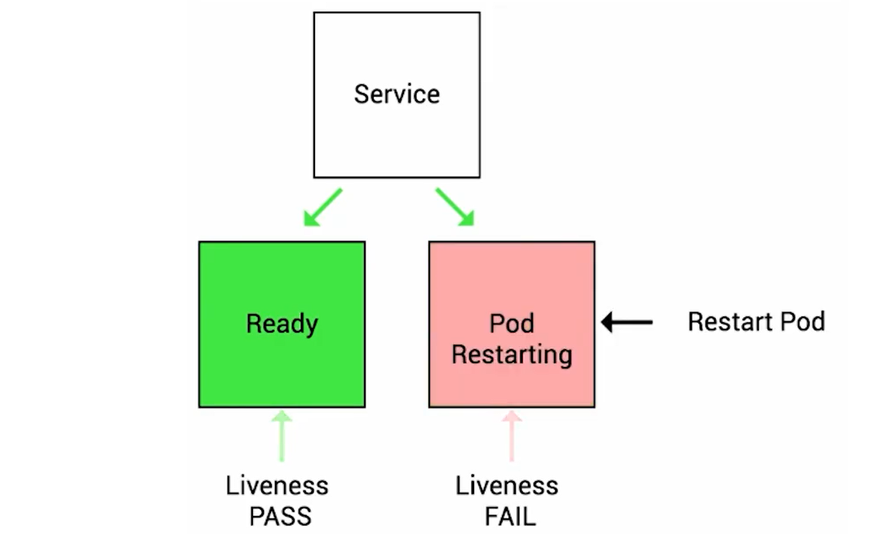
- Secure K8s
  - K8s Security
    - Application Security
      - Pod, Namespace, Node
      - RBAC, IRSA
    - DevSecOps->DevOps + Security-> Security of the container DevOps lifecycle
      - Authorization
      - Scan Repository
      - Scan running container
    - Security Compliance
      - FedRAMP, HIPPA, SOC etc
- Ops
  - Detective Controls
    - Collect and Analyse audit logs
    - Alarm on certain behaviour
  - Understand K8s termination lifecycle
    - Drain nodes
    - Use rolling Update
    - App handle gracefully termination
  - Incident response
    - Identify and isolation
    - Run load and penetration testing

K8s Security best practices?
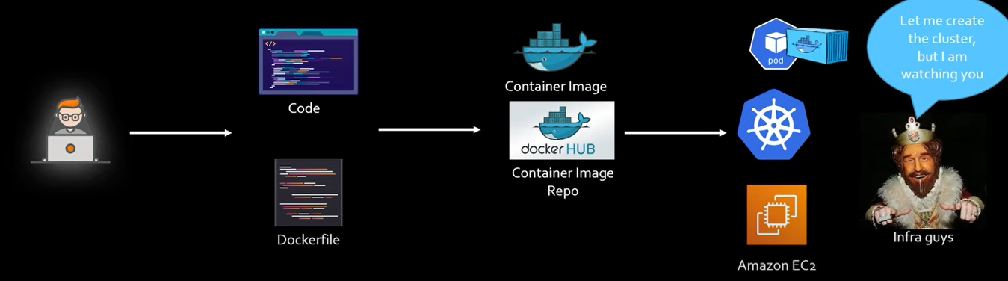
Development phase:
Code
Docker Image
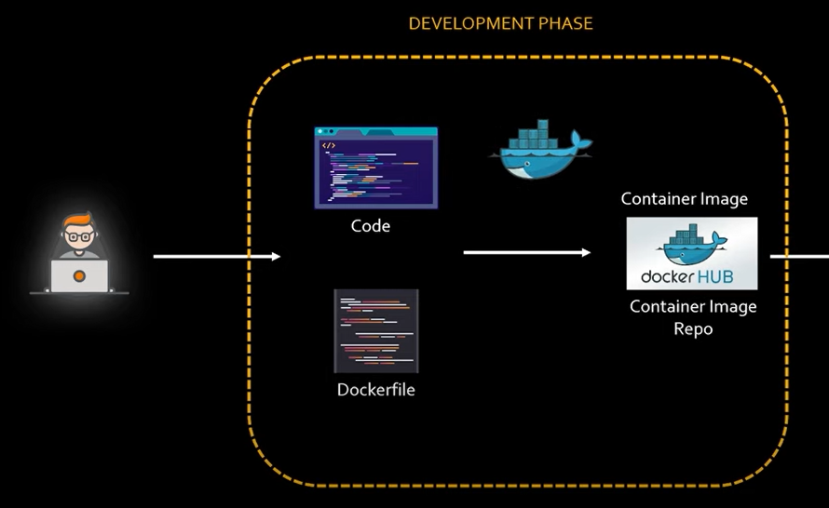
Development Phase Security Best Practices
- Create minimal images
- Reducing package, reduces attack surface
- Use multi-stage builds to reduce size
- Reducing the number of layers
- Run static scan for vulnerabilities
- Keep some scanning tools names handy (Clair, TwistLock, AquaSec)
- Use private repository
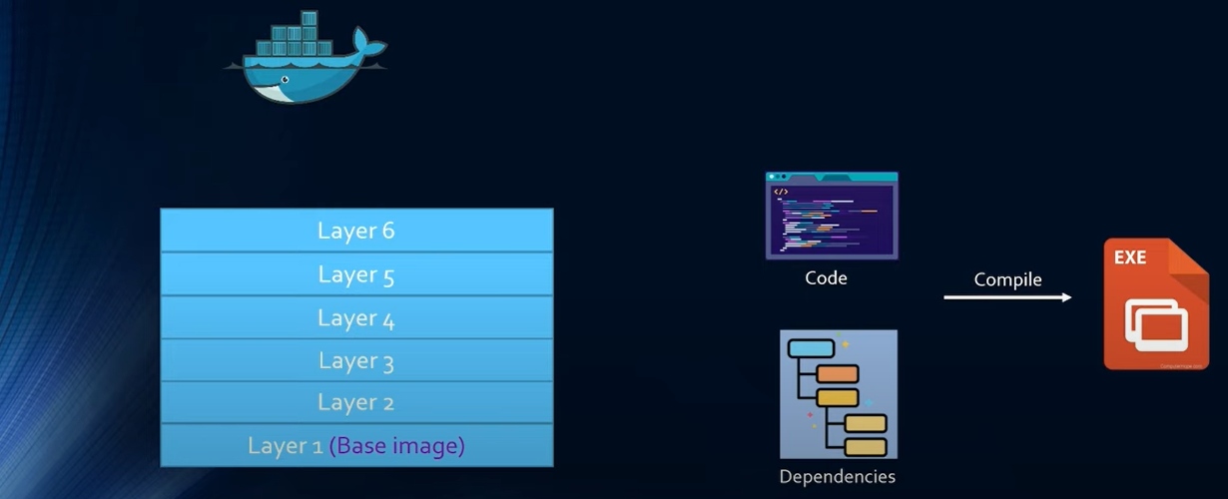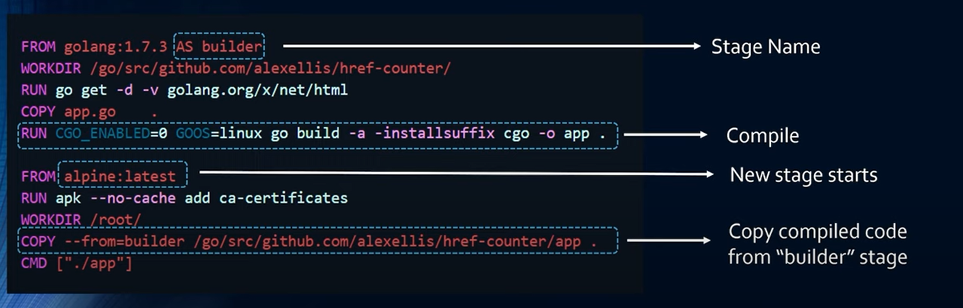
Infrastructure phase:
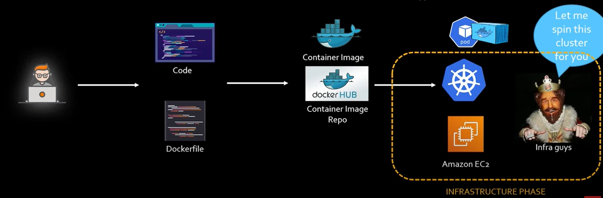
Infrastructure Phase Security Best Practices
- Use hardened AMIs
  - Reducing packages, reduces attack surface
- Run latest K8s version
  - Lots of security patches
- Run kube-bench for CIS benchmarking periodically (Vulnerability)
  - AWS X-Ray

Application phase:
Application Phase Security Best Practices
- Use namespaces to divide the cluster
  - Separate resource quota and access for each namespace
  - By default, all pods can talk to each other
- Use network policy to control pod traffic
  - Control traffic by IP, label, or namespace
- Implements RBAC
  - Specify separate roles for separate groups (admin, developer)
- Do not allow privileged escalation
  - Prepare for privileged Vs root
- Use OPA (Open Policy Agent) to enforce restrictions
  - Images are approved repo, namespaces with label with point of contact etc...
  - Using Gatekeeper
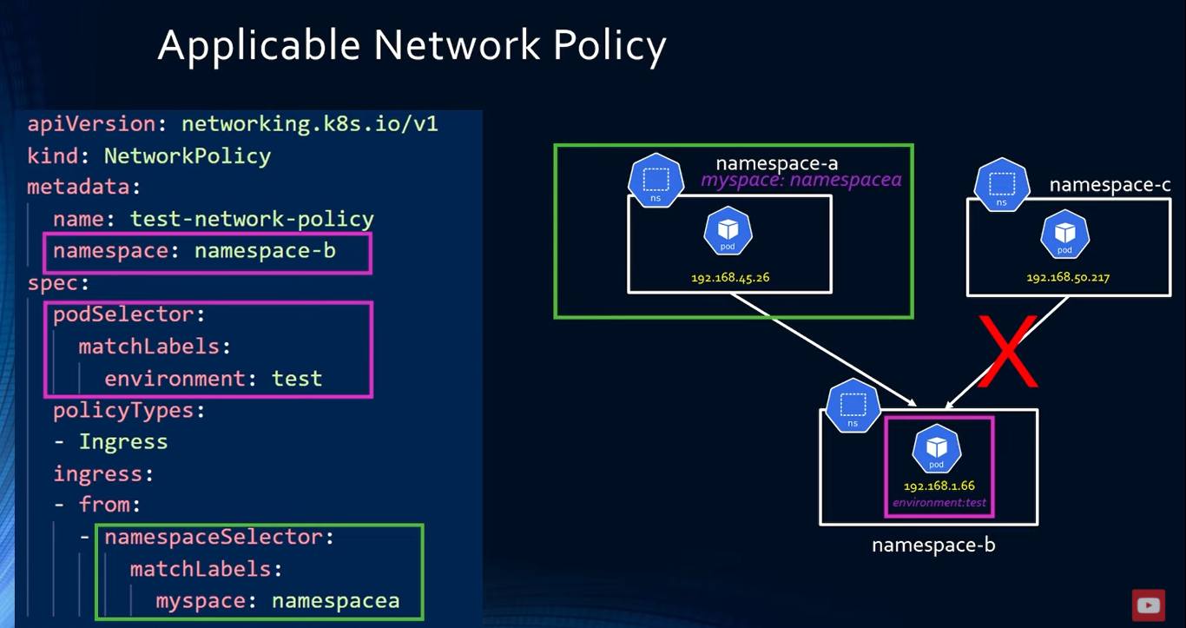

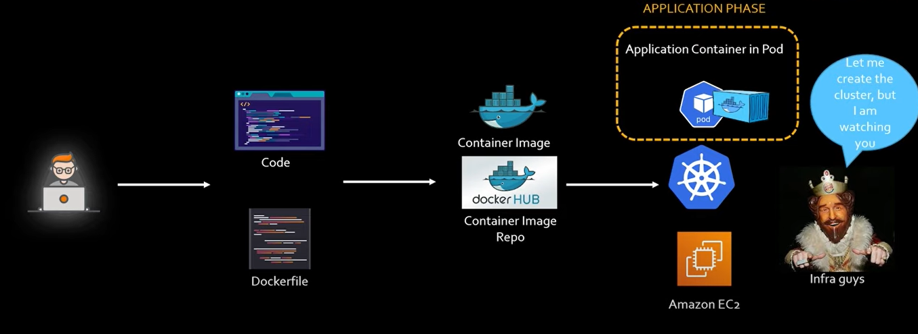
Detection phase:
Detection Phase Security Best Practices
- Run dynamic scan on running container
  - Keep some scanning tools names handy (TwistLock, AquaSec, Snyk)
- Enable audit logs
  - Create Alarm
